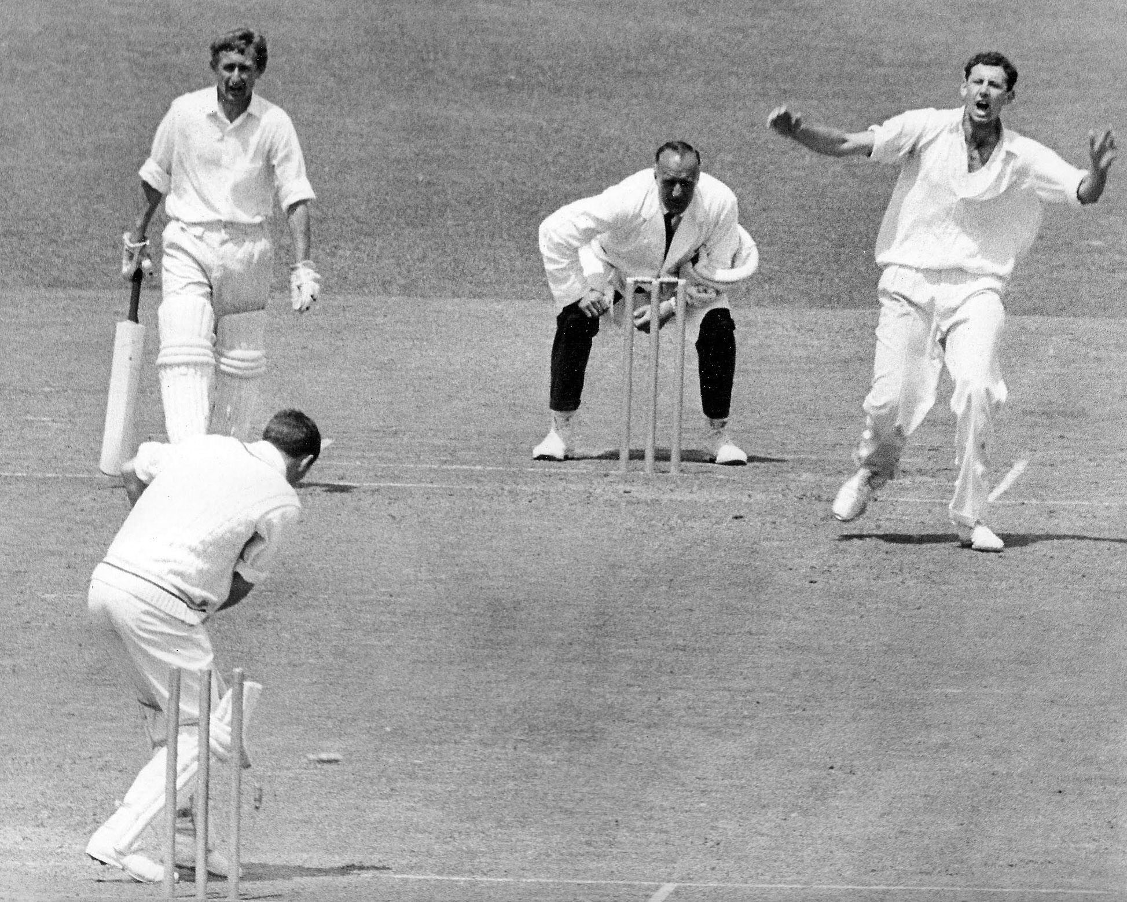

**BR Taylor bowls BD Smith, DO Neely non striker. Lancaster Park 2 January 1967**

**Canterbury 207 and 325/6 dec. Wellington 175 and 233. Canterbury won by 124 runs**